**Code:**

int ButtonState;

int a;

int b;

void setup()

{

Serial.begin(9600);

}

void loop()

{

ButtonState=digitalRead(2);

delay(1000);

if(Serial.available())

{

a=Serial.parseInt();

b=a*a;

Serial.println("Square of Number is: ");

Serial.println(b);

}

}

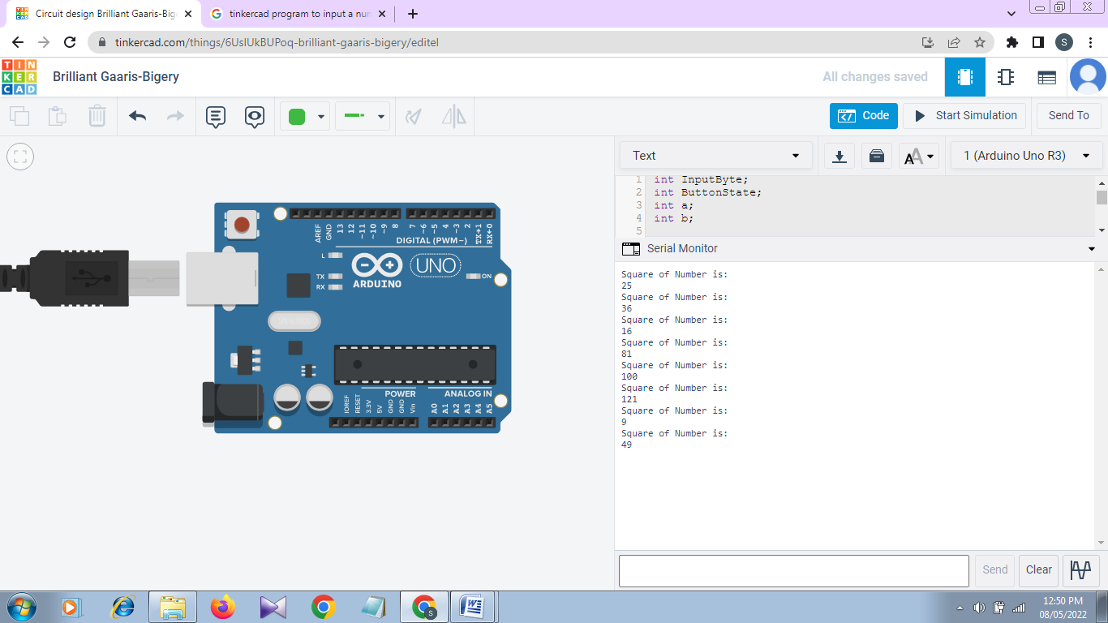**Output:**